Record No: 0667
GUALTER HUGH RODGER BELLINGHAM SOMERVILLE M.C. (Pat)
of The Old Mill Cottage, Adderbury, Oxfordshire

4th son of Bellingham Arthur Somerville (0631) by his wife Margaret Hall Clinch (0632).

Birth: 1 May 1894, at Ballyhenry, Ashford, Co Wicklow
Bapt: 2 Sept 1894, at St Audoen’s Church, Dublin
Marriage: 7 Sep 1925, at St Nicholas’ Church, Longparish, Hants to Heather Edith (0668) daughter of
Col Cecil Norris Baker (0669) of Indian Army
Death: 10 Jul 1947, at Adderbury. Bd 14 July 1947 at St Mary the Virgin’s Churchyard,
Adderbury

Source: Somerville Index

Notes: Served in Royal Warwickshire Regt. 1913-1939 and 1940-1945
World War I: British Expeditionary Force
Captured following Battle of Mons, Oct 1914
Escaped 3 times from POW camp, awarded Military Cross

Lt Col. Royal Warwickshire Regt.

Further researches on Military career:
( 1) Undated cutting from The Antelope, the magazine of the Royal Warwickshire Regiment:

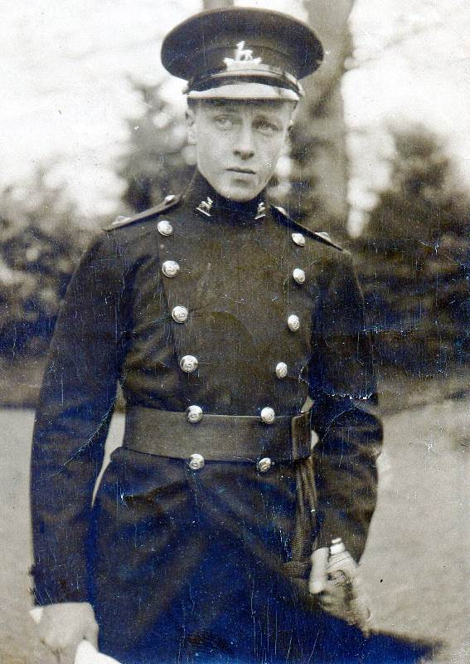
G.H.R.B Somerville

Lt.-Col. G. H. R. B. Somerville. M.C.

Pat Somerville joined the 2nd Battalion at Malta in 1913 and was taken prisoner near Ypres when a portion of the Battalion was surrounded. Captivity did not suit his adventurous nature and after a number of gallant but unsuccessful attempts at escape he succeeded in November 1917, crossing into Holland after a walk of over 100 miles and the fording of a number of rivers. For this fine exploit he was awarded the Military Cross.

After service at the War Office and with the 2nd Battalion in India, he took over command of the Depot in 1933 and later returned to the 2nd Battalion in England. He retired in 1939.

In the Second World War Pat had adventures as an Officer in Command of Troops on HM transports in what were known as dangerous waters. His ship was bombed and sunk off Greece and after being landed on Crete his ship was again bombed and nearly sunk in withdrawing from the Island.

He was demobilized in December 1946.

Pat was a very fine regimental officer in the best tradition. He was efficient in his work, was a good and keen games player and was beloved by his brother officers and particularly so by the men.

He was buried at Adderbury, his funeral being attended by
representatives from the Regiment . We offer our sympathies to Heather Somerville and her daughters in their great loss.

(2) Gazette No: 31759 published on the 27 January 1920. Page 13 of 20

SUPPLEMENT TO THE LONDON GAZETTE, 30 JANUARY, 1920.

War Office,
30th January, 1920.
His Majesty the KING has been graciously
pleased to.approve of the undermentioned rewards
in recognition of gallant conduct and
determination displayed in escaping or attempting
to escape from captivity, which services
nave been brought to notice in accordance
with the terms of Army Order 193 of
1919. To be dated 5th May, 1919", unless
otherwise stated: —

AWARDED THE MILITARY CROSS.

Capt. Gualter Hugh Rodger Bellingham
.Somerville, R. War. R.

(3)

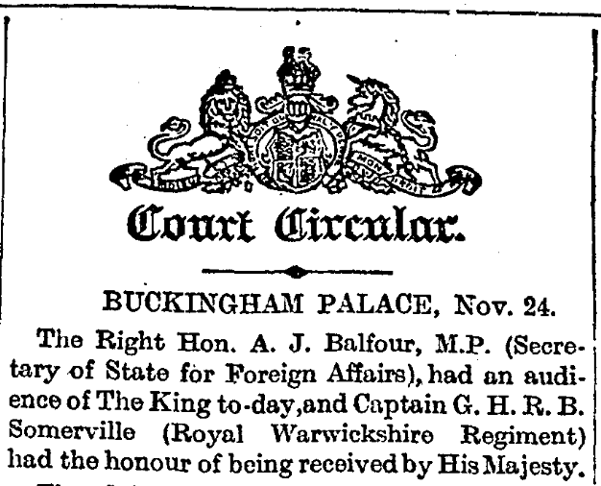
The Times, Monday 26 Nov 1917

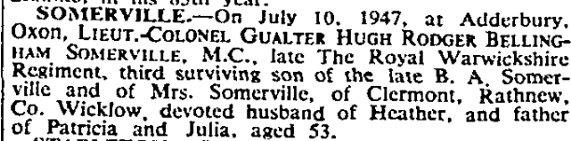 (I suggest the Death notice be placed at the end)

The Times, 14 Jul 1947
(4)
Escape attempts:

The plan was to get into a sack with room for plenty of stuffing all round it and to be carried out of the camp as “waste paper.”

Everything was ready and I was actually sitting in the sack as a final test when the alarm went, a Russian had been caught trying to get away, a roll call was held, and all the camp searched. Everything to do with my scheme was founds, framework, maps and all, this was followed by arrest and court martial. The sentence was only a fortnight’s solitary confinement, but it cooled one’s ardour for the time being.

The Russian attempt had been a good show. An aged general, over sixty years of age, crawled down a drain and was only waiting for darkness to emerge outside the camp when he was discovered by the cleaner of the said drain.

Our excitement as regards the course of the war at this time was very intense, especially as the Germans continually claimed victories, the Somme battles were ranging and periodically Zeppelins passed westwards over the camp on their way to carry out their bombing raids on England.

There followed the cold winter of 1916-1917 and two of us decided to make use of this cold spell to bring off an escape.

To get out of the camp by the main exit one had to pass through three gates, the innermost one of which was always kept locked; the outer two, though some high iron railings and the outer barbed wire fencing, were not locked, but had a sentry patrolling in between them. The outer windows of the building we lived in looked out on to these iron railings. These windows were securely fastened up by iron hasps, but we noticed that if we could only get out of one of these windows we would avoid having to negotiate the locked door, and by scaling the railings when the sentry was not looking, we would only have one more gate to get through to be free. We made our plan.

Everything went well. For months we worked on the making of German uniforms in which we dressed and made ourselves into quite respectable-looking German soldiers. One very snowy night, after hours of patient work – as it had to be noiseless – we sawed the iron fasteners of the outer window. The sentry was sheltering from the snow behind a pillar in the railings on the far side of the gate from us. Once out of the window, we quickly scaled the railings, expecting at any moment to receive a bullet in the back of our anatomies. We turned right and walked straight out of the outer gate. All was clear, but just at that moment a German under-officer was coming down the road. He accosted us. Where were we German soldiers going at that time of the night, what were our names, would we be back soon. One of us could speak German, the other hardly. Hesitation caused suspicion. We were brought back to the guard-room. In the bright light our disguise was easily discernible. Cells till morning for further investigation.

Further investigation led to a remand.

Written by Pat Somerville for The Antelope, magazine of the Royal Wawickshire Regiment.
Transcribed by D R G Gilmour, July 2011.

Note: The cuttings are poor photocopies which were amongst family history papers in the possession of Joy Goss who died in July 2009 and passed to David Gilmour, her twin sister’s son.

(5)
Additional Research about Strohen POW camp:

2ND Lt Robert Stanley Capon was held at Strohen for about 4 months before being transferred to Holzminden in the late autumn of 1917. It is likely that he was there when Pat Somerville made his home run.

The camp was situated on a moor north of the road between the villages of Ströhen and Wagenfeld. The camp accommodation was in wooden huts and had previously housed Russian and Serbian p.o.w.’s. At Ströhen the food was very poor and many of the prisoners were badly undernourished. The camp had its own group of thespians; one review they put on began with the words “Come to sunny Ströhen with its golden sands and its beautiful blue lagoons”. Capon describes the camp as a detestable spot. The golden sands were a mess of dirty earth; the “blue lagoons” were two of three muddy ponds intended to drain off the all too plentiful water from the peat bog in which the camp was situated. The camp huts were not very clean and the mattresses were stuffed with paper. At the end of the first six weeks one of the lumps was a ginger beer bottle! Despite all this he notes it was the pleasantest camp he visited, across the moorland was the Ems river and once across that it was only a few miles to the Dutch border. He notes “The whole camp was escape mad” every two or three weeks they were heartened with the news of another successful escapee reaching England. Capon joined a group of men who were tunnelling. The tunnel ran from a point beneath the floor of a hut situated about 20 ft from the boundary of the camp. As there was no cover outside the camp at the point selected under whose shelter they could emerge, they decided on the following scheme. When they were sure they had arrived at a point a yard or two outside the barbed wire boundary fence they would work towards the surface, supporting the earth with props until only a few inches of earth remained. They intended to allow this to fall in by removing the props at the moment when the sentry was at the end of his beat furthest removed from the tunnel and bolt for it. A dark night was to be chosen and the party would consist of six men. The first job was to calculate the distance required, and then they removed several floor boards which were fitted with dummy nails. Tunnelling began through the soft earth, very soft, after a few feet of tunnelling the roof fell in, fortunately before they emerged from under the hut. After observing that the boards used to support tier beds were hard and not very springy they and it was decided to use them in an inverted V structure, the beds were duly partially stripped of boards as needed with the unfortunate next donor being distracted by a visit to the canteen whist the boards were removed. The next problem to overcome was the foul air and the need to provide fresh air to the worker at the face. This was overcome buy the construction of a centrifugal pump using a cigarbox and pasteboard but they were delayed by the construction of a pipe for sometime. This was resolved by wrapping cloth on a broom handle, then coating with adhesive purchased in the canteen and then removing the handle. Work continued under the constant fear of being found out. Capon never got to see the tunnel finished. He attempted to escape from the camp bathroom. This had been used by a chap called Knight to make the first successful escape. Capon and an accomplice devised a plan to remain in the room following a bathing parade. There was a barred window at the side of the bathroom facing away from the camp and a short distance away a boiler on wheels with an opening at one end provided with a swinging door. The boiler did not appear to be used and he thought how pleasant it would be to be ensconced in it waiting for nightfall. The one problem was the bars on the window which were of iron about 1 inch wide and 1 ½ inches thick. Mentioning this to a friend he was informed that a table knife could be used to cut metal that was not too hard by striking the edges of two knives together so as to make a saw. They immediately brought some knives from the canteen, prepared them and tried them on a metal bar of a window in their hut. To their surprise they found that rapid progress could be made; the knife became ineffective after a few minutes but with a supply of newly prepared knives they calculated that if the material of the bars of the bath room window was not harder than that which they used in their experiment they could cut through a bar in about twenty minutes. The friend went with the first bathing party and cut through the bar as far as he could. Capon was to follow in the next parade and finish the job and hide in the boiler. A distraction was arranged to fool the guard counting the party that all was correct. The plan went as expected, the bar was cut, Capon was having smuggled in a haversack with food, compass and a map, removed the severed bar and stepped through the window – and as he did a German solider with a rifle stepped out of the door adjoining the window. Capon was sentenced to a month solitary confinement in the camp, which he describes at “the pleasantest period I spent as a prisoner of war”. The routine was not too harsh and by bribing the guards small comforts could be obtained. Exercise was taken in pairs on the quadrangle, and improvised game of squash and tennis could be played against a wall. Chess was played by shouting the moves to your opponent although confusion could arise if several games were in progress at the same time. There was no close supervision in the evenings and the men took full advantage visiting each others rooms and arranged gramophone and bridge parties. During his four month stay at Ströhen some 20 odd men are thought to have escaped.
Source: http://www.66squadron.co.uk/biogs/capon.htm

- Cutting from The Antelope - Four Days and Three Nights

(7) (Debriefing account to be provided by WBRBS)

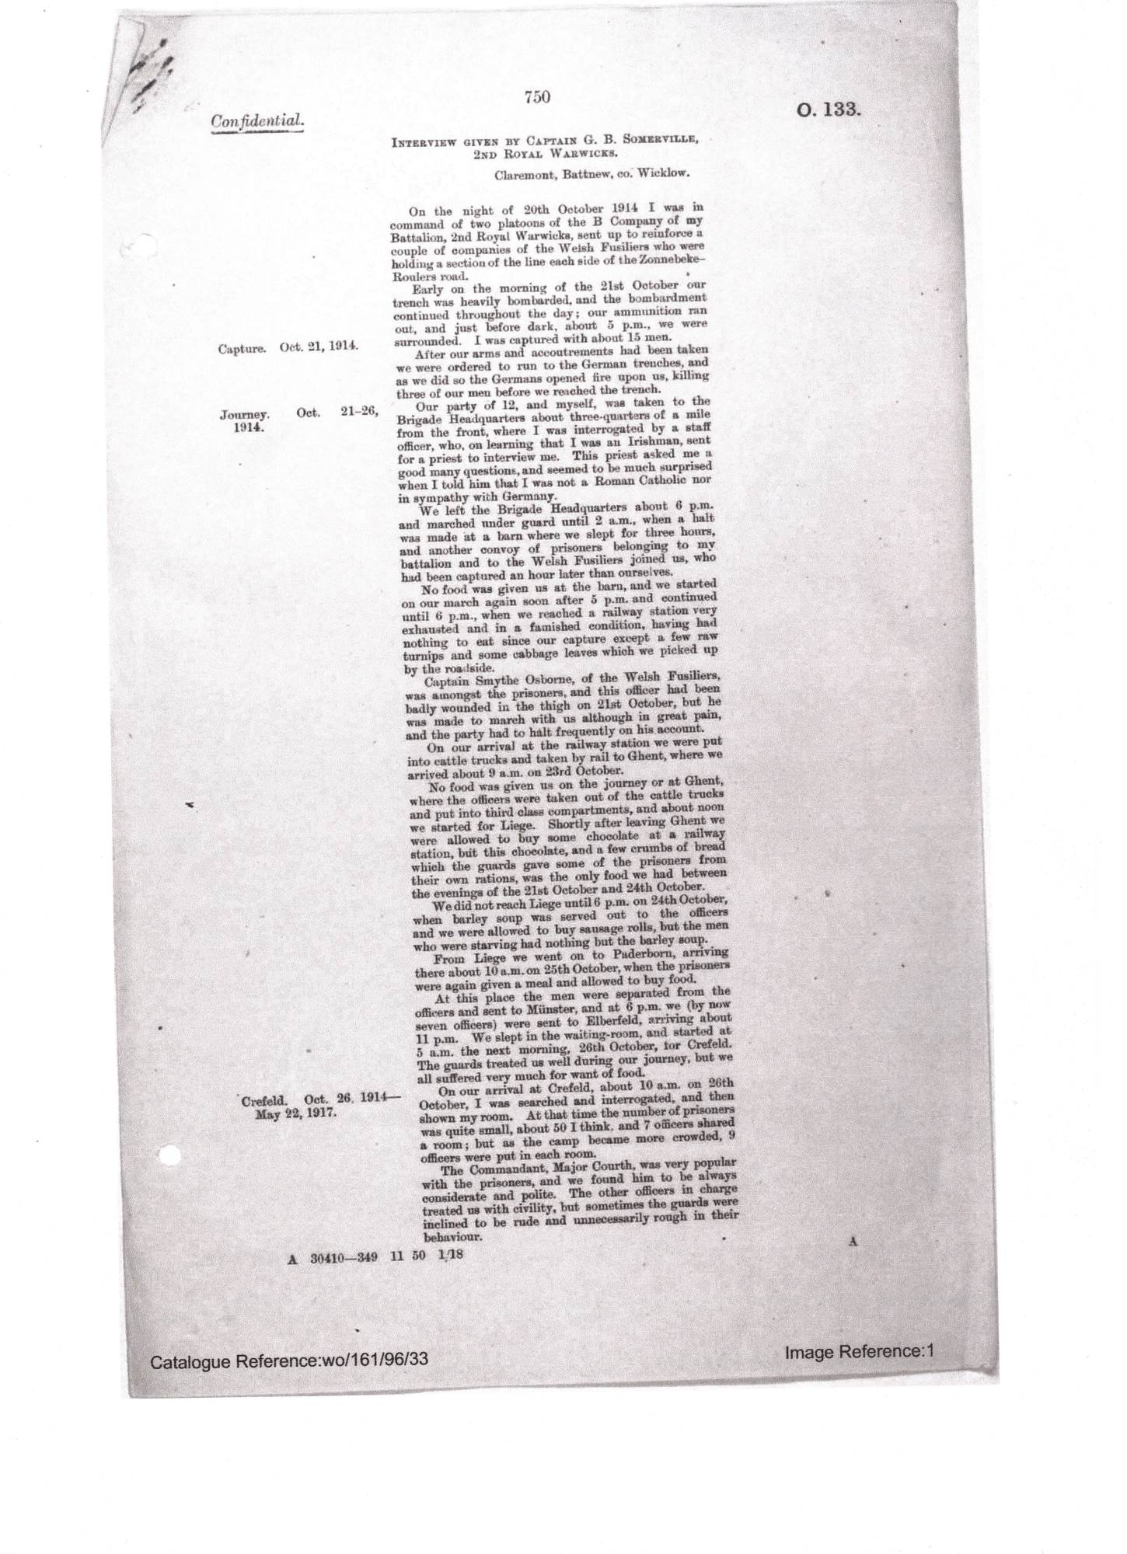
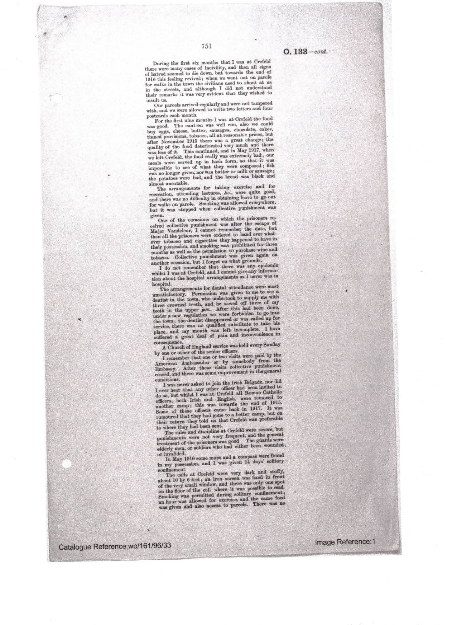
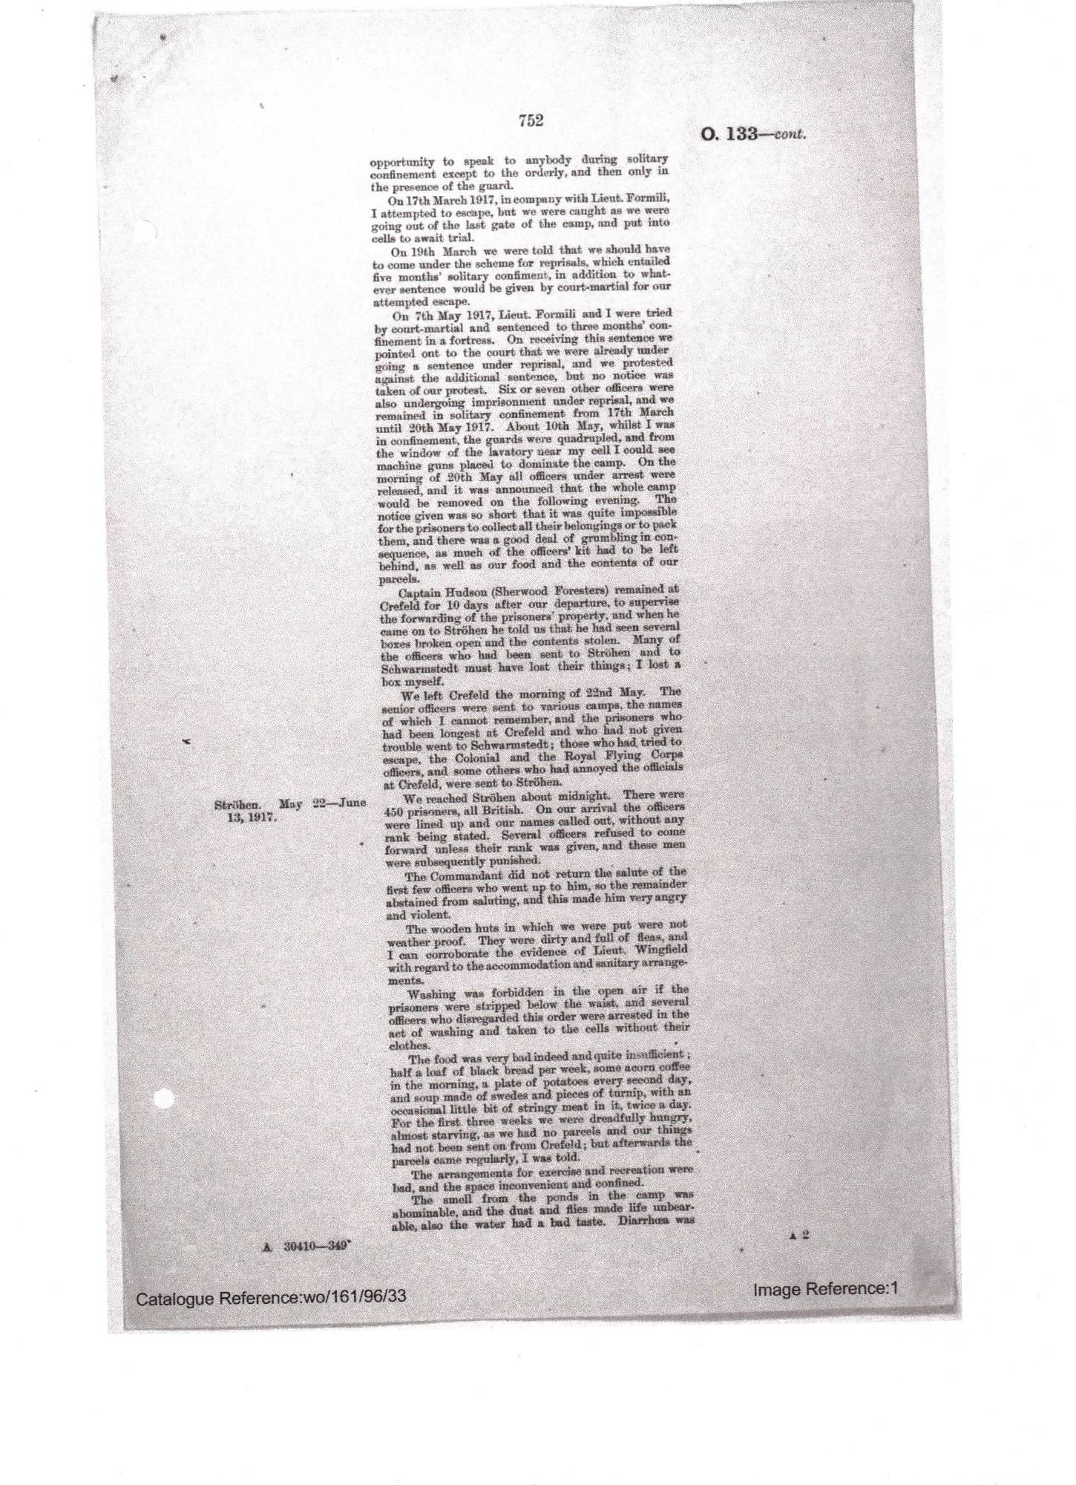
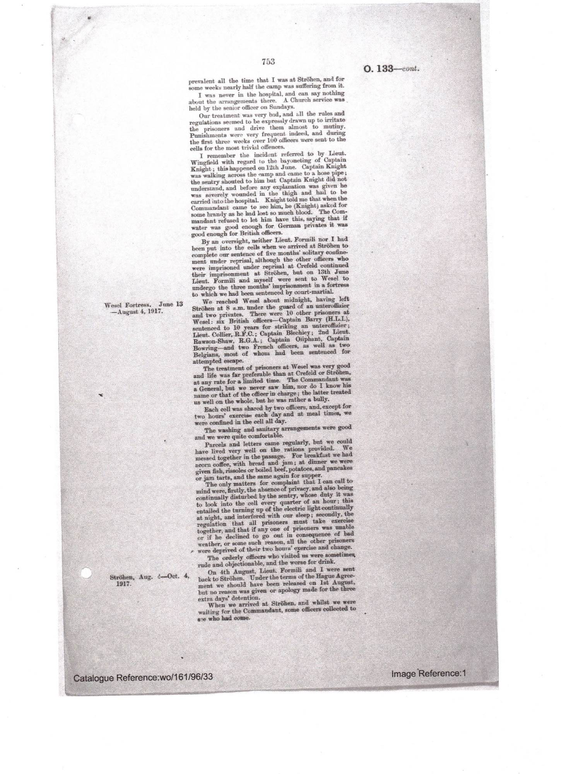
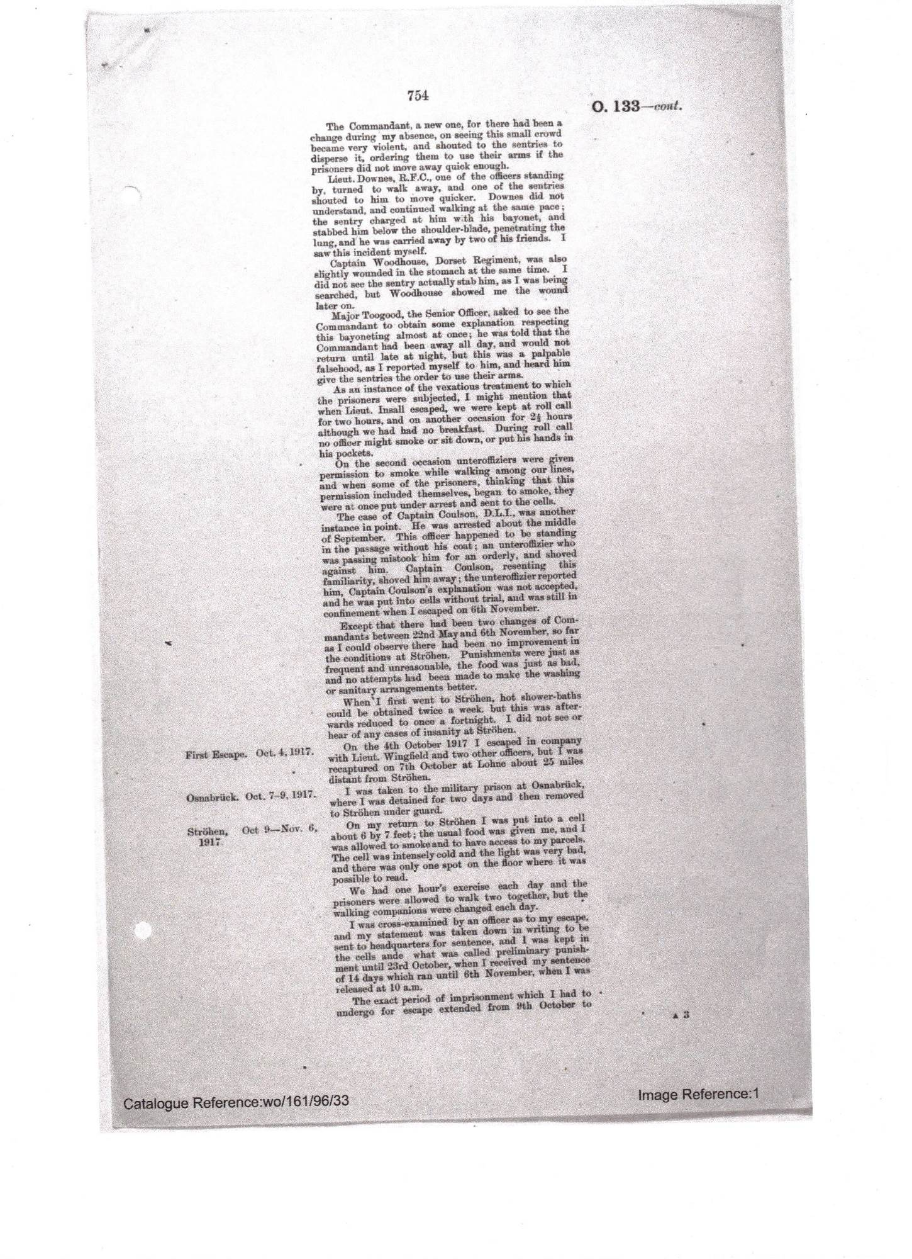
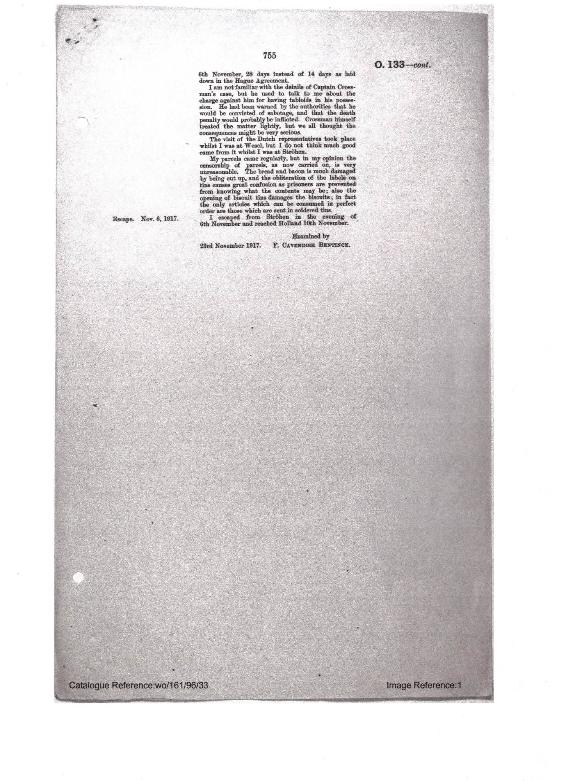
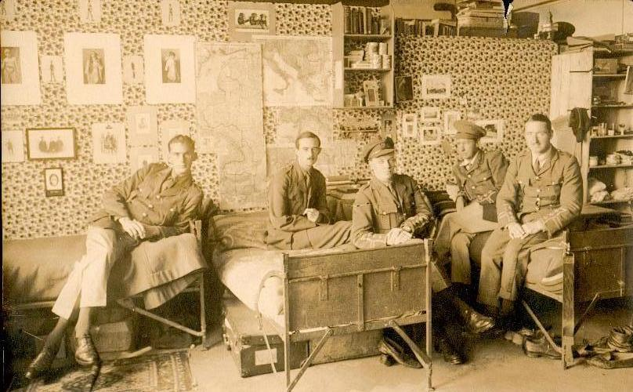
Pat Somerville (third from right) at Krefeld.

WBRBS remembers Pat as being a thoroughly outgoing person, making the most of every situation. A vivid memory is the enthusiasm with which he used to enter into the game of ‘Murder’ at Clermont in 1945/6. As the victim, he got hold of somebody’s lipstick and ‘slashed’ his throat, groaning in agony.
Story also has it that all the girls fell for him, although he hadn’t the looks of his brothers. His charm attracted, among others, Diana Somerville, one of the Cork family, and most recently, the late Hilda Sandys (of Dargle Hill) told us how she used to cycle the 15 miles to Clermont for the dancing in the hope that Pat would be at home. RMJBS related how Heather(0668) was invited to Clermont by Jim(0663), but ended up with Pat!

WBRBS from personal knowledge and conversation with Regi
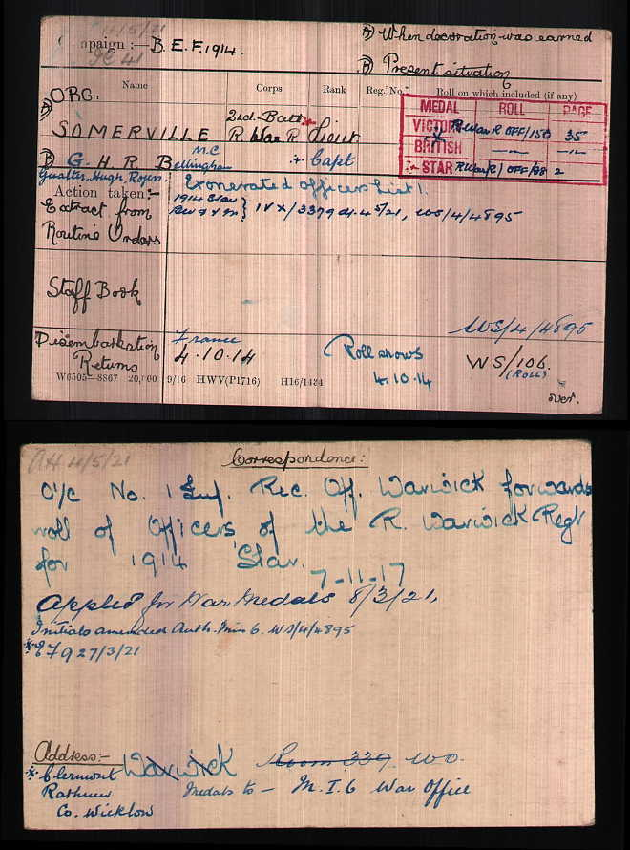

Transcripts of Letters to Merlie Truell:
c/o Mrs Baker ,
The Curacy
Longparish,
Whitchurch
Hants
Aug 19th 1925
My dear funny old nieces

It was very good to get your combined letter the other day which I found easier & more delightful to read than you will this (possibly and probably – but not certainly – ha – that was a joke!). I would have sent a note in reply earlier but for that beastly malaria bug which walked out again and left me (illegible) for some days.

I’m having a very good time here with “Nauntie” and all the family – but as your great brains may well imagine, rather a “buzzy” one, both from taking quinine and the general rush of “trousseau” and that that sort of thing. Four of us are going to the theatre in London on Saturday & I may be crossing over to Ireland that night – or if not on Sunday or Monday as I want to have some time at Clermont before you all go. I’ve such a lot of letters to write, I must really end having only scribbled a very few lines I know – but you understand, couldn’t he?!
Best love from your
wobbly old uncle Pat

PS to Julie – many thanks for your 2nd letter. Very many thanks for the 3rd.

PPS to Merlie – very late I know, but all best wishes for your last birthday. I’m going to London tomorrow and will see what I can do there for it for Nauntie and myself as there are no shops here. P.
Clermont
Rathnew
Co. Wicklow
May 15 1927
My dear Merlie

You have probably noticed that I left a good many days between getting your letter + picking up my pen to write in reply – The truth is really that, firstly, I’m always bad at raising energy to write, and secondly, that there was nothing interesting to write about before - there isn’t now, but never mind –

It has been terribly quiet since you all left, and we have really done nothing interesting since. I’ve had a couple of exciting golf matches against Ede + Bill Herafath, but, of course, as we had no respectable caddies they fell rather flat!! We’ve now won three matched to their two – but more by flukes than good play.

I liked your description of the journey over – the crossing is always bad enough, but when you’ve several young relatives being continuously ill at intervals (or even feeling like it) it must be rather worse.

I have now started to work up for my exam for promotion (it is now May 16th) + so I am all alone in the house as the others have all gone to Glendalough – One of my exams comes off in July + the other in October – but I can always work much better when I know there’s no one else anywhere near – so I hope they will go out very often –

I hear Mike is better – good – but that poor Rachael [feeling] miserable. Give her my love + tell her that Count Whatnot hopes she will soon be better.
I must now get on with work again – good luck during the term,

Give my love to all,

Yr uncle (as ever) Pat
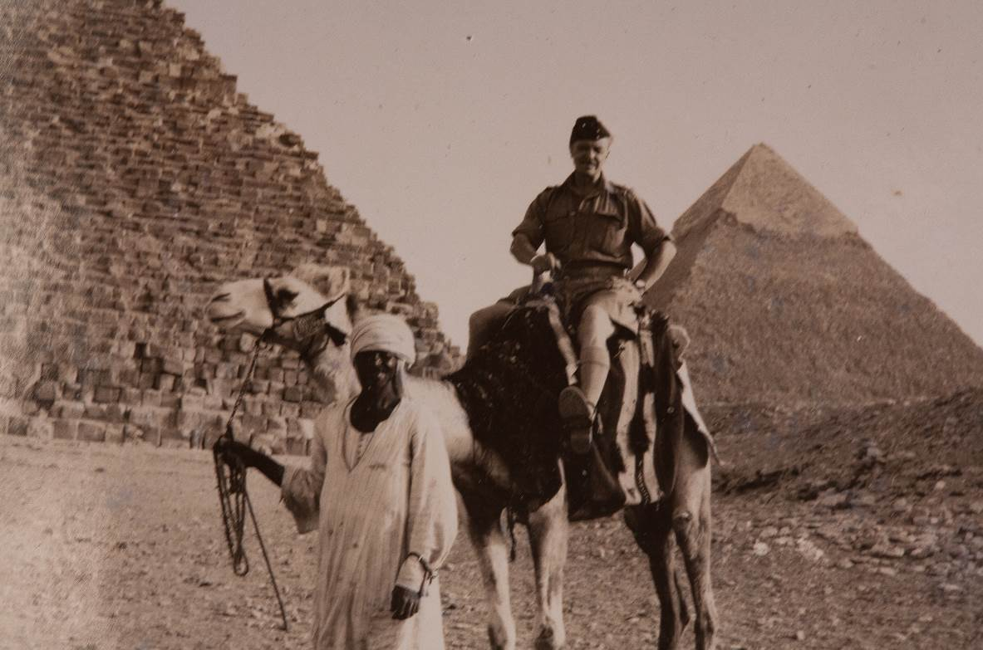
Pat Somerville, cerca 1941.
Source:Patrick Nicholas, son of Patricia May Naomi Nicholas (nee Somerville), eldest dau of Pat Somerville and Heather (nee Baker).

